Nom: ____________
J’aime.... les couleurs

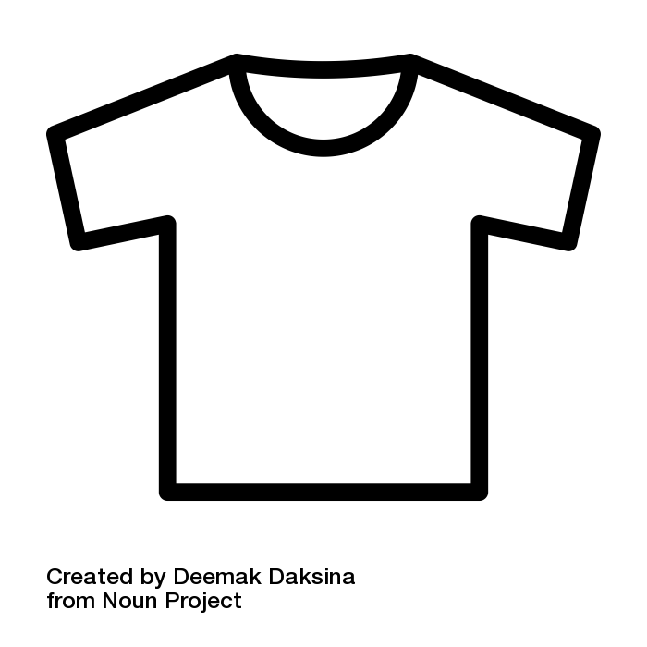 | J’aime le t-shirt blanc
 | ______________________________________________________
  

