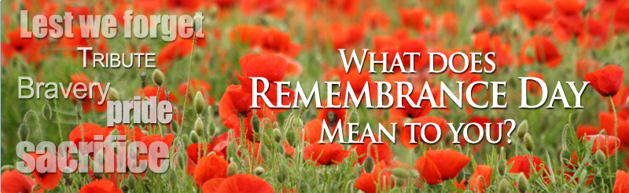

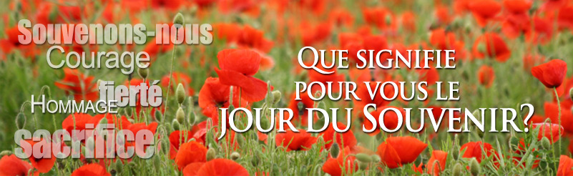

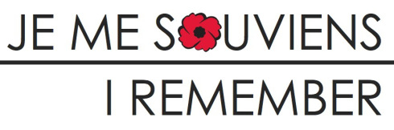

http://www.gitescanada.com/bb_vets_stories_winner.cfm
http://www.bbcanada.com/bb_vets_stories_winner.cfm
http://ahemmayispeak.wordpress.com/2012/11/11/remembrance-day-what-it-could-be/

