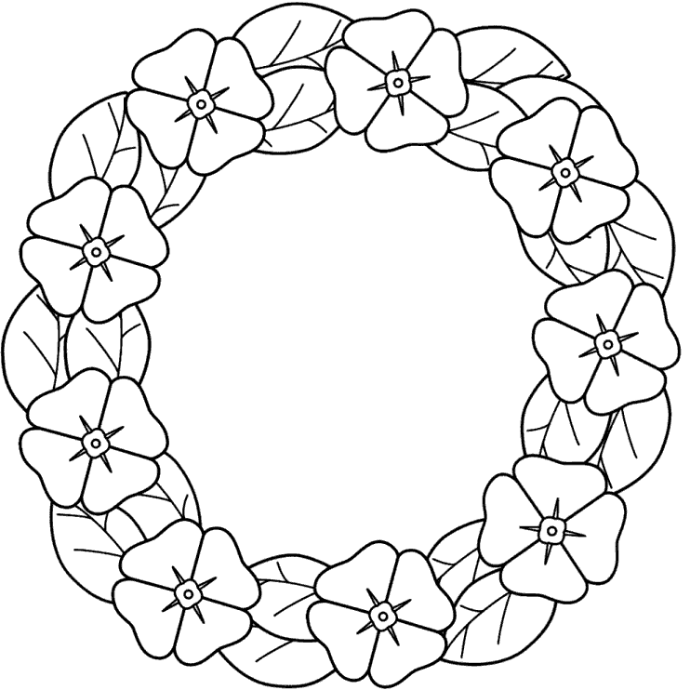

http://www.bigactivities.com/coloring/remembrance_day/poppies/poppy_wreath.php
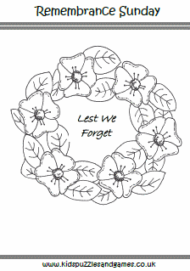http://www.kidspuzzlesandgames.co.uk/holidays/remembrance-sunday/#.VFBxSfnF-So

http://www.bigactivities.com/mazes/remembrance_day/easy/poppy_wreath.php
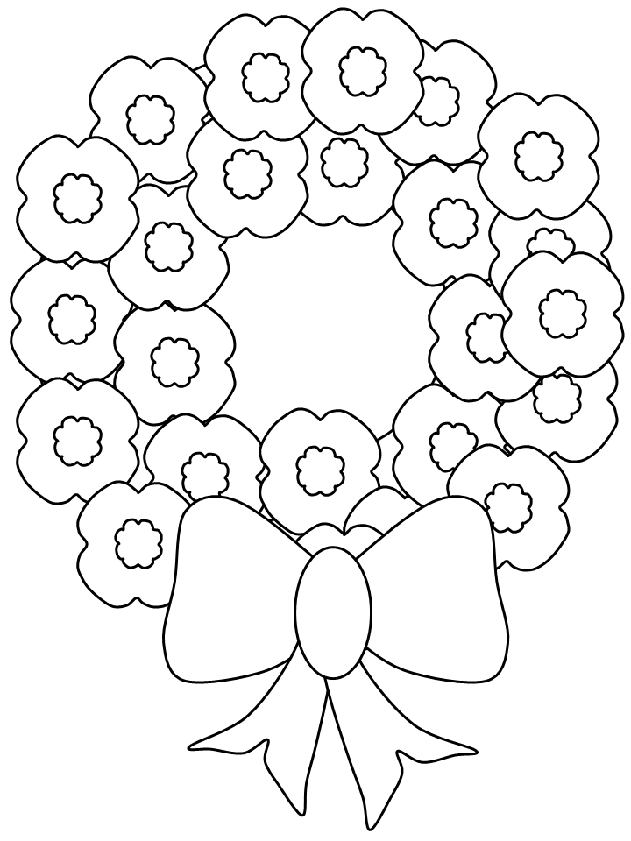

http://www.coloring.ws/t.asp?b=m&t=http://www.coloring.ws/remembrance/14.gif

