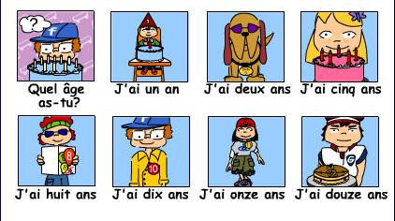

http://samaneras.blogspot.ca/2011/06/blog-post_28.html
http://www.bbc.co.uk/schools/primaryfrench/index_flash.shtml

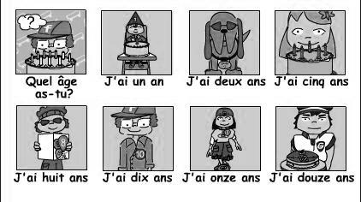

http://samaneras.blogspot.ca/2011/06/blog-post_28.html
http://www.bbc.co.uk/schools/primaryfrench/index_flash.shtml

