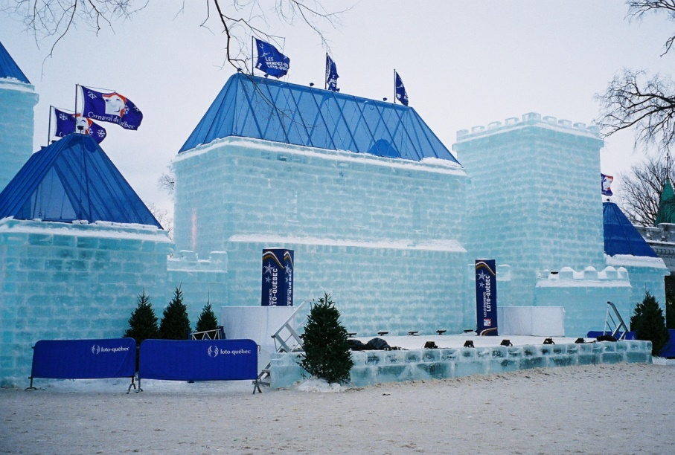
https://commons.wikimedia.org/wiki/File:Carnival_1.jpg
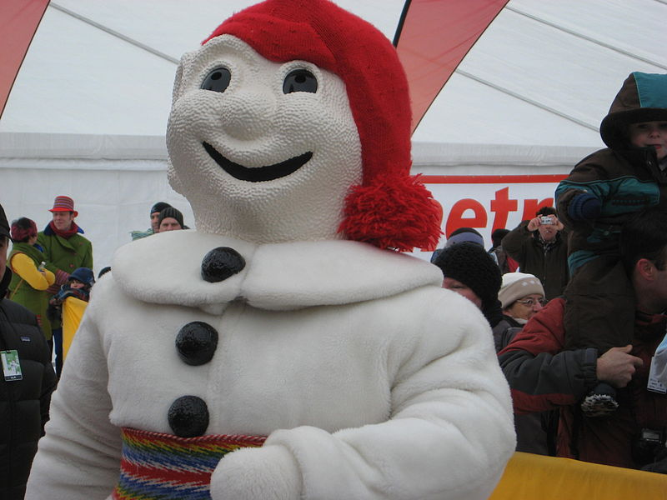
https://commons.wikimedia.org/wiki/File:Carnaval_Qu%C3%A9bec_2011.jpg?uselang=en-gb
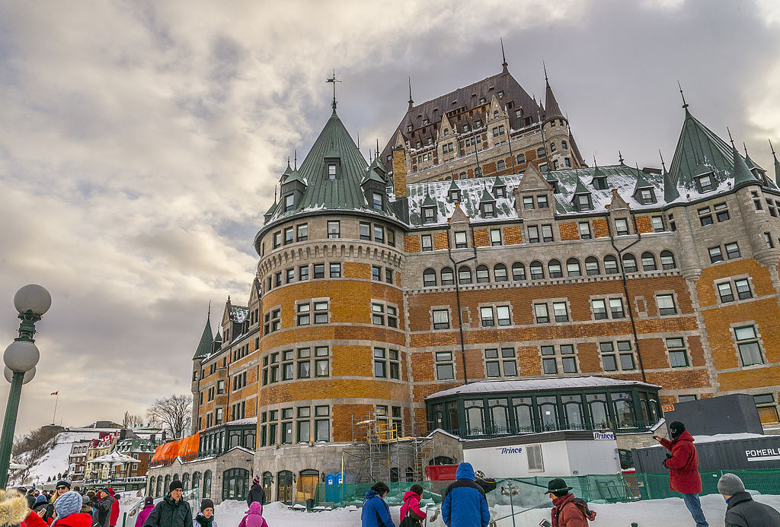
https://commons.wikimedia.org/wiki/File:Le_60e_Carnaval_de_Qu%C3%A9bec_(12665365115).jpg?uselang=en-gb
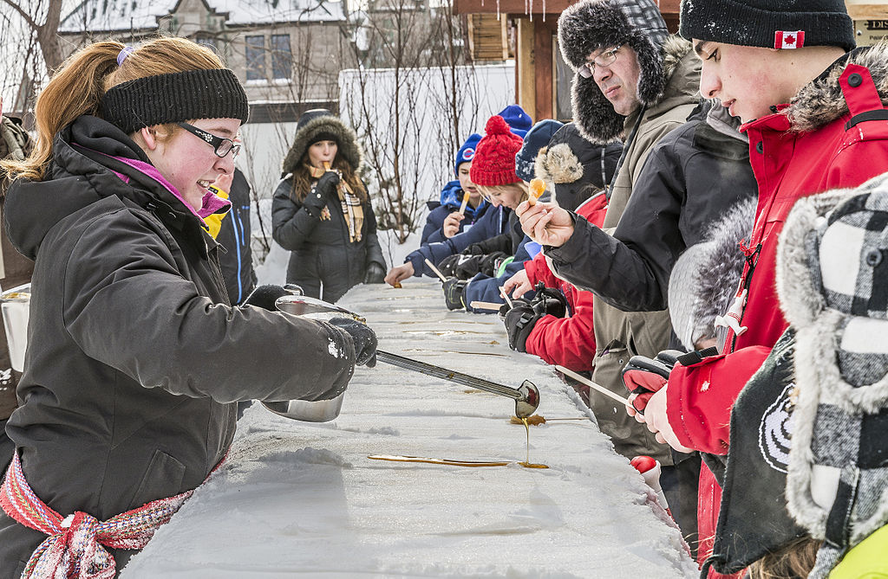
https://commons.wikimedia.org/wiki/File:Le_60e_Carnaval_de_Qu%C3%A9bec_(12665471913).jpg?uselang=en-gb
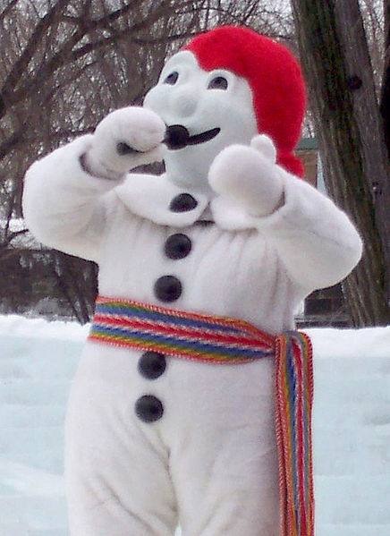
https://commons.wikimedia.org/wiki/File:Bonhomme_carnaval_-_2006-02.jpg?uselang=en-gb
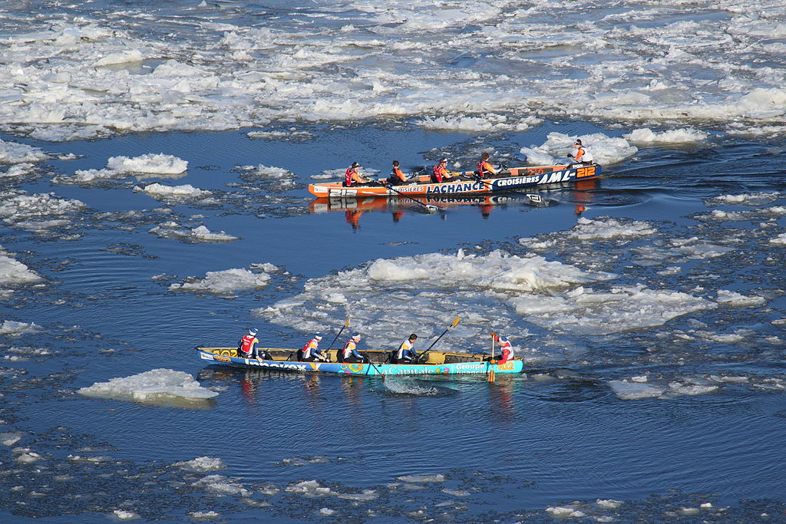
https://commons.wikimedia.org/wiki/File:Ice_canoeing_Quebec_2016_2.JPG?uselang=en-gb
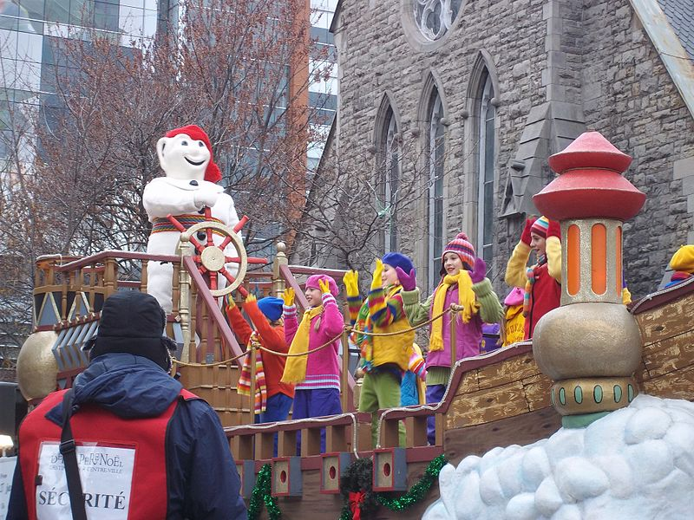
https://commons.wikimedia.org/wiki/File:Defile_du_Pere_Noel_Montreal_2011_-_040.jpg?uselang=en-gb
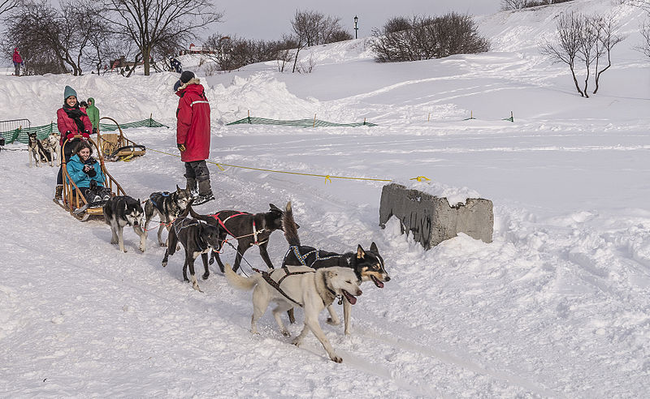
https://commons.wikimedia.org/wiki/File:Le_60e_Carnaval_de_Qu%C3%A9bec_(12665469423).jpg?uselang=en-gb
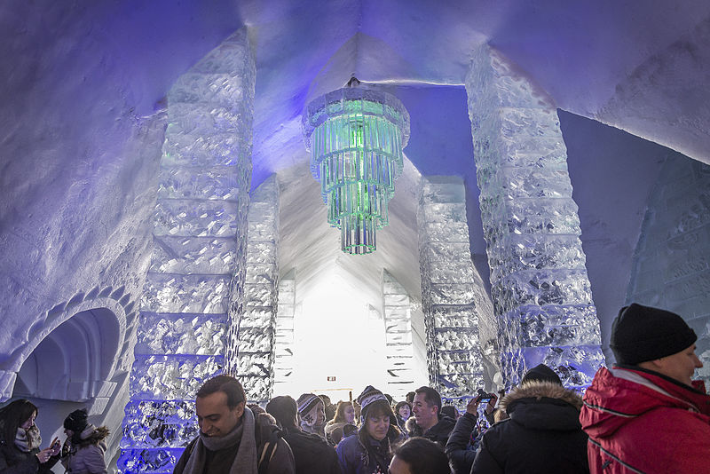
https://commons.wikimedia.org/wiki/File:H%C3%B4tel_de_Glace_(12665427543).jpg
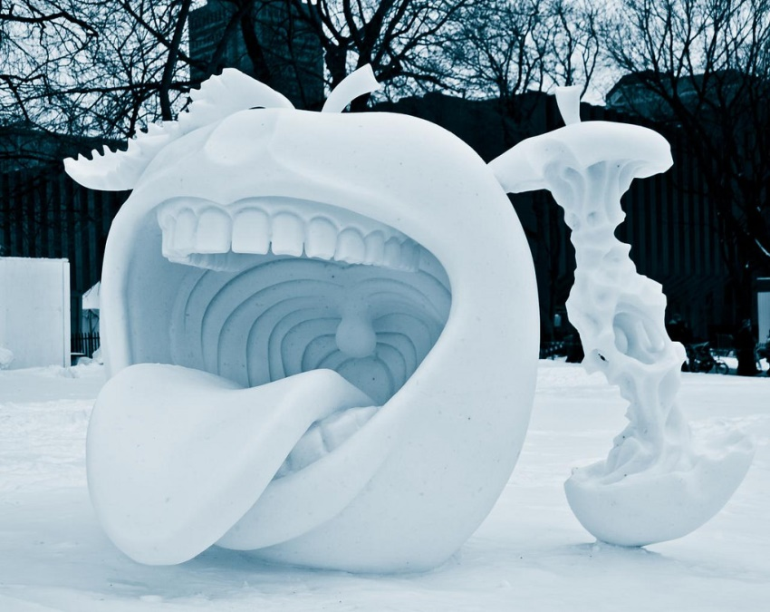
https://www.flickr.com/photos/pagarneau/5419390635
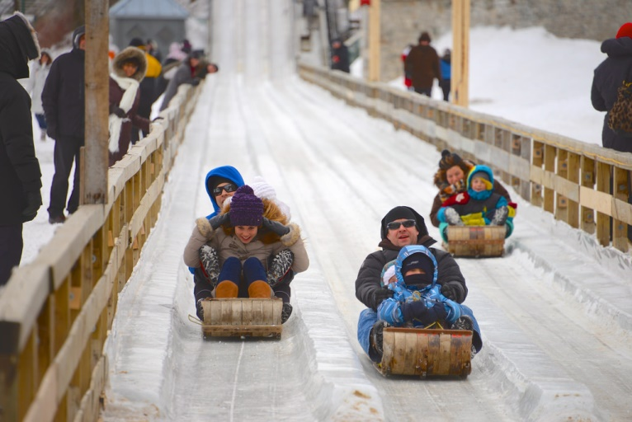
https://www.flickr.com/photos/15609463@N03/8475330162
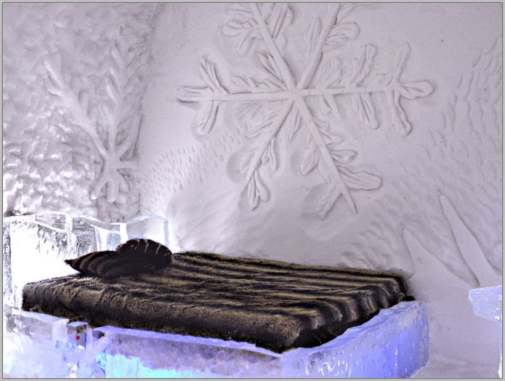
https://www.flickr.com/photos/melolou/8540669852

